Principle of Software Testing life cycle   
  
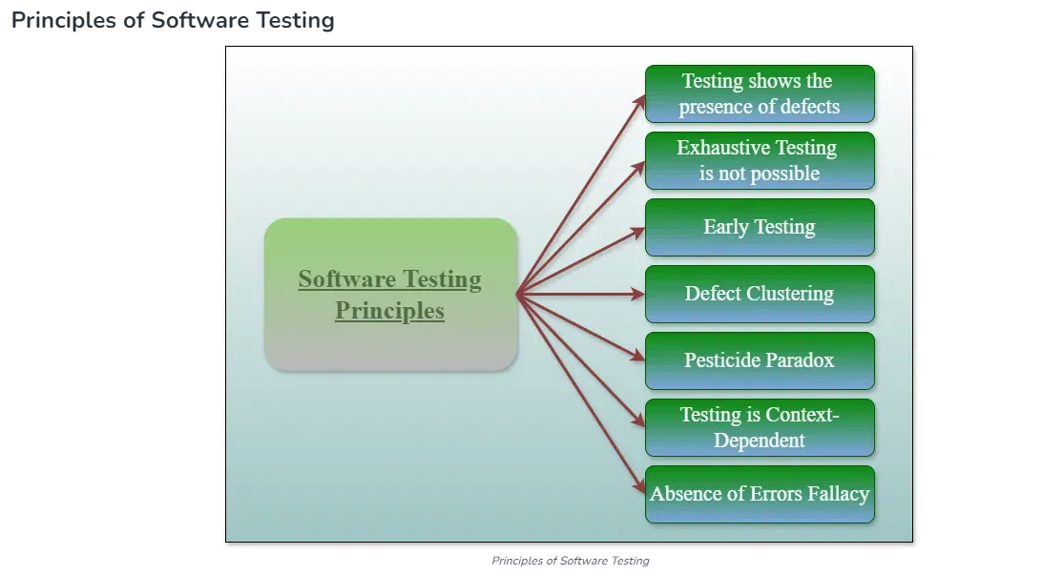  
  
  
  
  
  
**1. Testing shows the Presence of Defects:**

The goal of software testing is to make the software fail. Software testing reduces the presence of defects. Software testing talks about the presence of defects and doesn’t talk about the absence of defects. Software testing can ensure that defects are present but it cannot prove that software is defect-free. Even multiple tests can never ensure that software is 100% bug-free. Testing can reduce the number of defects but not remove all defects.  
  
2. Exhaustive Testing is not possible:

It is the process of testing the functionality of the software in all possible inputs (valid or invalid) and pre-conditions is known as exhaustive testing. Exhaustive testing is impossible means the software can never test at every test case. It can test only some test cases and assume that the software is correct and it will produce the correct output in every test case. If the software will test every test case then it will take more cost, effort, etc., which is impractical.  
  
  
  
**3. Early Testing:**

To find the defect in the software, early test activity shall be started. The defect detected in the early phases of SDLC will be very less expensive. For better performance of software, software testing will start at the initial phase i.e. testing will perform at the requirement analysis phase.  
  
**4. Defect Clustering:**

In a project, a small number of modules can contain most of the defects. The Pareto Principle for software testing states that 80% of software defects come from 20% of modules.  
  
**5. Pesticide Paradox:**

Repeating the same test cases, again and again, will not find new bugs. So it is necessary to review the test cases and add or update test cases to find new bugs.  
  
**6. Testing is Context-Dependent:**

The testing approach depends on the context of the software developed. Different types of software need to perform different types of testing. For example, the testing of the e-commerce site is different from the testing of the Android application.